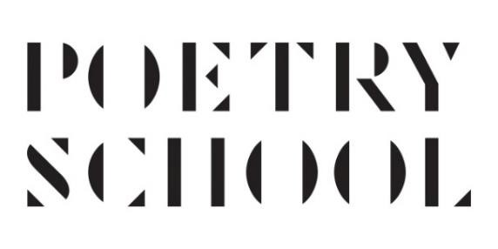
Bursary Application Form Autumn Term 2022

Before applying for a bursary, please check your eligibility for our concessionary rates.

1. Disabled/Full time carers – |  | 50%
2. Under 30 – |  | 30%
3. Students/Low Income – |  | 20%
4. Local Resident – |  | 10%

Concessions may not be combined and evidence must be provided where required.

To apply for a bursary please complete the following information. Bursaries are funded by donations from our students and are discretionary. We are able to offer funding up to 100% of course fees, however the maximum we are able to fund on our seminar courses is 50%. Please only apply for the amount you require. If you are successful in your application for a bursary, you may be asked to provide a 50-word minimum report on your experience. You also agree to adhere to our terms and conditions. You agree to accept the bursary in writing should it be offered. If for any reason you are unable to participate in the course you have been funded for, you agree to inform us as soon as possible. Failure to do so will affect future bursary applications.

First name:

Surname:

Email:

Gender: Male Female

Other (please specify)

Age: 18-25
26-40
41-59
60+

This information is for internal reporting purposes only and is subject to our Data Privacy Policy, which you can view on our website.
What Poetry School activity, or activities are you applying for funding to support?

Please note we do not provide bursaries for one-to-one tutorials and funding for more than one activity will depend on the funding available each term. If you are applying for more than one course, please put them in order of preference.

Have you been awarded a grant from the Poetry School in the past?
Yes No

How much do you wish to apply for? (£)

Please briefly outline your financial need:

Please outline what you hope to gain as a writer from taking part in the activity applied for:

Please attach copies of any supporting documents as evidence of financial need (please do not send originals as we cannot return them).

Please return this form to administration@poetryschool.com by Friday 19 August in application for the Autumn 2022 Term.

