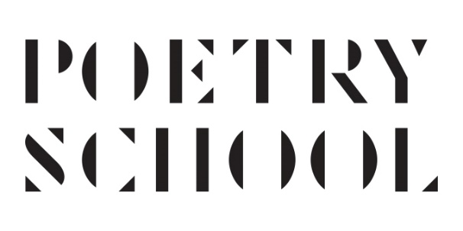
Aesthetica Creative Writing Award
Free entry application

Dear Poets,

One of our long-term students, Tamsin Hopkins, has won the Aesthetica Creative Writing Award with a poem written on a Poetry School course and has generously offered to use part of her prize to provide free entries for the Aesthetica competition next year to 10 Poetry School students.

You can find more information on the Aesthetica Creative Writing Award here: https://aestheticamagazine.com/creative-writing-award/
Poetry submissions should be no more than 40 lines, and entries are open until 31 August 2021.

If you would like to apply for the free entry, please fill in the form below and send it to administration@poetryschool.com with "Aesthetica application" in the subject line by 15 June 2021.

First name

Surname

Email

Gender
Male Female

Other (please specify)
Age
18-25
26-40
41-59
60+

This information is for internal reporting purposes only and is subject to our Data Privacy Policy, which you can view on our website.

How long have you been writing poetry? What do you think are the main themes / interests of your work?

Which Poetry School courses have you attended? Please give details, and say what you think you gained from any courses you have taken.

Have you had any poetry published? Please list magazines / books / websites or competition success?

Please briefly outline your financial need:

